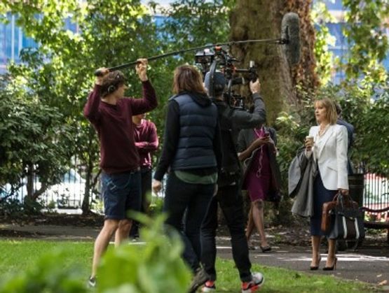

**Helping fresh new talent enter the Capital’s film industry**

London’s ongoing film and TV production boom shows no sign of slowing.

With current levels of production there is an ever-increasing need for homegrown emerging talent.

Making that initial step into a career in the screen industries requires aspiring professionals to have personal connections or undertake multiple unpaid internships to build up their CVs and gain high profile film credits: **critical to success in a highly competitive sector.**

Apprenticeships provide a great opportunity to introduce a more diverse talent base to the industry while at the same time providing opportunities for trainees to earn and learn on the job. However, work in the screen industries is essentially freelance in nature with each production starting and finishing in a relatively short timeframe. **And as a result, current apprenticeship schemes lack relevance and flexibility.**

The short-term and freelance nature of contracts makes it difficult to devise an apprenticeship scheme able to support the apprentice fully to satisfy the key requirements as prescribed by the Apprenticeships, Skills, Children and Learning Act 2009.

Additionally, the government mandatory apprenticeship levy does not sit comfortably in the film industry. Production companies, large and small, consider it a tax with little benefit and short-term, freelance productions find it hard to accommodate longer term apprenticeship programmes or to meet the required outcome parameters such as apprenticeship standards.

**The result of these factors: Vital work experience in the screen industries is often beyond the reach of many talented individuals**

How are we helping local talent? FilmFixer has placed social value, employment, and skills development at the heart of its new Film Office Service contracts. The company been attempting to tackle this problem for many years by finding opportunity whenever possible with productions willing to participate and help new entrants gain a foothold in the industry.

Priority has been on placing residents in each local borough from diverse communities and backgrounds within the locations department as grassroots support working as paid runners and marshals. Recent suitable candidates have been sourced through a range of organisations and charities such as: ScreenSkills, Calltime Company and Creative Sparkworks, Fully Focused and Soapbox FilmFixer also began to encourage larger productions to create opportunities, to ensure that training and job opportunities were available to local people. To show the value that filming could bring to the boroughs, FilmFixer had two priorities:

• To enable residents, seeing filming going on in their areas, to access available opportunities and find work in the local film industry

• To allow everyone to participate, no matter what their background, gender, race, age, disability, sexual orientation, or geographic location In exchange new talent would bring a fresh perspective to productions as well as a range of skills and expertise.

Just two recent examples of success: Charles Roskilly, Lime Pictures FilmFixer encouraged Lime Pictures to take on some talented local runners when they filmed in Camden earlier this year. Sue Russo – FilmFixer’s Training and Development Manager – worked in conjunction with Camden council and their communities team to source aspiring new entrants into the film industry. Camden local Charlie won the position and spent ten weeks as a runner this summer. He impressed Lime Pictures so much that he was invited to return on a full-time contract for the next series.

FilmFixer were delighted to have facilitated Charlie’s first step onto the industry ladder and to have created opportunity of such value. Charles career has since progressed further. After additional experience as a runner, he has moved up to the position of Agency Researcher.

Two trainees were taken on for work experience for four days during the filming in St Mary’s Gardens, Lambeth, from the local programme Creative Sparkworks. For local trainees Omar Dick and Robin Barrett, exposure to a production of this scale was a real shot in the arm for their careers, as employers are always looking for as many high-profile film credits as possible. “It was hard work but Robin said afterwards the range of tasks had given him a good grounding in how the locations department operates, adding that the team at Triton Films was so friendly it was a pleasure working for them and he really felt like part of the team.

—————————————————————————————-

FilmFixer is committed to finding meaningful career ladder opportunities for industry talent. To affect change, FilmFixer is working in collaboration with Screen Skills and DIVA who are supporting “trailblazer” employer groups. These groups are developing new apprenticeship standards, which are replacing the previous frameworks in England and will make apprenticeships a more realistic choice for the film industry at large. FilmFixer plans to introduce an additional annual apprenticeship that will recruit directly from its client boroughs. The company will proactively signpost emerging talent towards “trailblazer” employers, who we see as the future of the film industry.

**If you want to get involved, head over to** [**screen skills resources and information page**](https://www.screenskills.com/information-and-resources/?q=&subjects=New%20entrant%20schemes&industries=&types=&careerStages=&pageIndex=1) **where you can find opportunities for new entrants and advice about taking your first steps into the industry.**